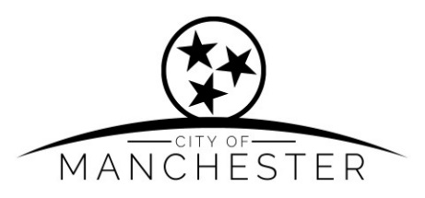
SAFETY COMMITTEE MEETING
APRIL 13, 2026 @ 5:00P.M.
City Hall Board Room

- CALL THE MEETING TO ORDER:

- ATTENDANCE:

- APPROVAL OF AGENDA:

- CITIZEN COMMENTS:

- APPROVAL OF THE MINUTES:
03/09/2025 Safety Meeting Minutes

- COMMENTS FROM DEPARTMENTS:

CODES DEPARTMENT
- Departmental Review
- Employee Safety Review

FIRE DEPARTMENT
- Departmental Review
- Annual Report

POLICE DEPARTMENT
- Departmental Review
- Vape Ordinance Discussion
- Blue Line Solutions

- NEW BUSINESS:

- OLD BUSINESS:

- ADJOURNMENT:

www.cityofmanchestertn.com
LIVE STREAMING https://www.youtube.com/@CityOfManchesterTennessee

